Original Paper
Journal of Rainwater Catchment Systems Vol.27/No.2/pp.69-70

Journal of

Rainwater
Catchment
Systems

Instructions to Authors (I)
-Preparation of English Manuscripts-

Ichiro Usui¹ and Hanako Shigen²

Abstract: Instructions are given to prepare the manuscript of a Japanese paper submitted to the Journal of Rainwater Catchment Systems. Being a model in itself, the document demonstratively prescribes the layout of the manuscript. Manuscripts should be typed on one side of white A4 size paper when they are submitted. Accepted manuscripts will be off-set printed. Titles of papers, names and affiliations of authors, abstract, keywords, main texts, headings, references, equations, mathematical symbols, captions of figures and tables and so on should be in specified fonts. All references cited should be collected together at the end of the paper. Figures and Tables with their captions should be placed appropriately.
Keywords: Journal; Manuscript; English instructions; Rainwater; Hoover Dam

1 Introduction
This text gives the instructions to be respected when an English manuscript is prepared for the Journal of Rainwater Catchment Systems. Typed in a standard form with the layout, font face/size and line spacing to be used, this electric instruction could also be a template for MS-Word users contributing their papers to the journal. To facilitate the manuscript review, numbering should be made every ten lines on your manuscript.
As for the length of a paper, 6 or less pages are desirable. An accepted paper is off-set printed as it is submitted.

2 Layout
The manuscript of a paper should be typed on one side of white A4 size paper. Top and bottom margins should be 25mm. The font should be of typical Roman face such as Times.
At the top of the first page the manuscript should include the header that the journal editor provides. Fill either of “Original Paper, Technical Paper, Review Paper，or Technical Notes/Review" in the text box in the center of header depending on the aim using 12pt font. The paper should contain a title section, the main text, and a list of references, if any. It may also contain equations, figures, and tables. Footnotes to the text and appendices should not be used.

2.1 Title section
The title section is in one column and consists of the title of the paper, the name(s) of the author(s), an abstract and keywords. Left and right margins should be 30mm. If the paper is serialized, the title should be numbered as (I), (II), etc., and a subtitle should be provided below it. Each word in the title except connective, preposition and article should start in a capital letter. The full affiliation(s) and address(es) of the author(s) should appear as footnotes, where Arabic numbers are used for identification. The title, the subtitle, and the name(s) of the author(s) should be centered. The abstract may be 75 to 200 words. The keywords less than ten should be listed making off by a semicolon (;). The abstract and the list of keywords should be right justified by use of the “automatic hyphenation” available in the MS-Word. The font to be used is shown in Table 1.

Table 1: Font in title section
Title | 13pt bold
Subtitle | 10pt
Name(s) of authors(s) | 11pt
Abstract | 9pt
Keywords | 9pt italic
Affiliation(s) | 8pt

2.2 Main text
The main text should be in two columns separated by a 8mm wide space. Left and right margins should be 16mm. Lines should be single-spaced, and right justified using the “automatic hyphenation”. The font should be in 10pt. Italics may be used to emphasize terms.
Up to three levels of headings are allowed. They should be all blocked against the left-hand margin, numbered decimally, and typed in 10pt bold font. 1 blank line should be left above each heading.

2.3 References
The name(s) of author(s) and the year of publication should appear in the citation of a reference. If there are more than two authors, the names of the authors but the first one should be replaced by ”et al.” in italics.
Written in 9pt font, all the references cited are collected in an alphabetical order by the first author's name at the end of the manuscript. They are to be numbered as [1], [2], etc. Capitalization of each word follows as it is in the reference. The heading References should be in 10pt bold font.

¹Research Associate, Ehime Rainwater Harvesting Institute, 3-5-7 Tarumi, Matsuyama, Ehime 790-8566, Japan
²Professor, Graduate School of Hydrology, Rainwater University, 123 West Precipitation Street, Lansing, NY 14882, USA (Corresponding Author) E-mail: rain@rainwater-u.ac.jp
2.4 Equations and mathematical symbols
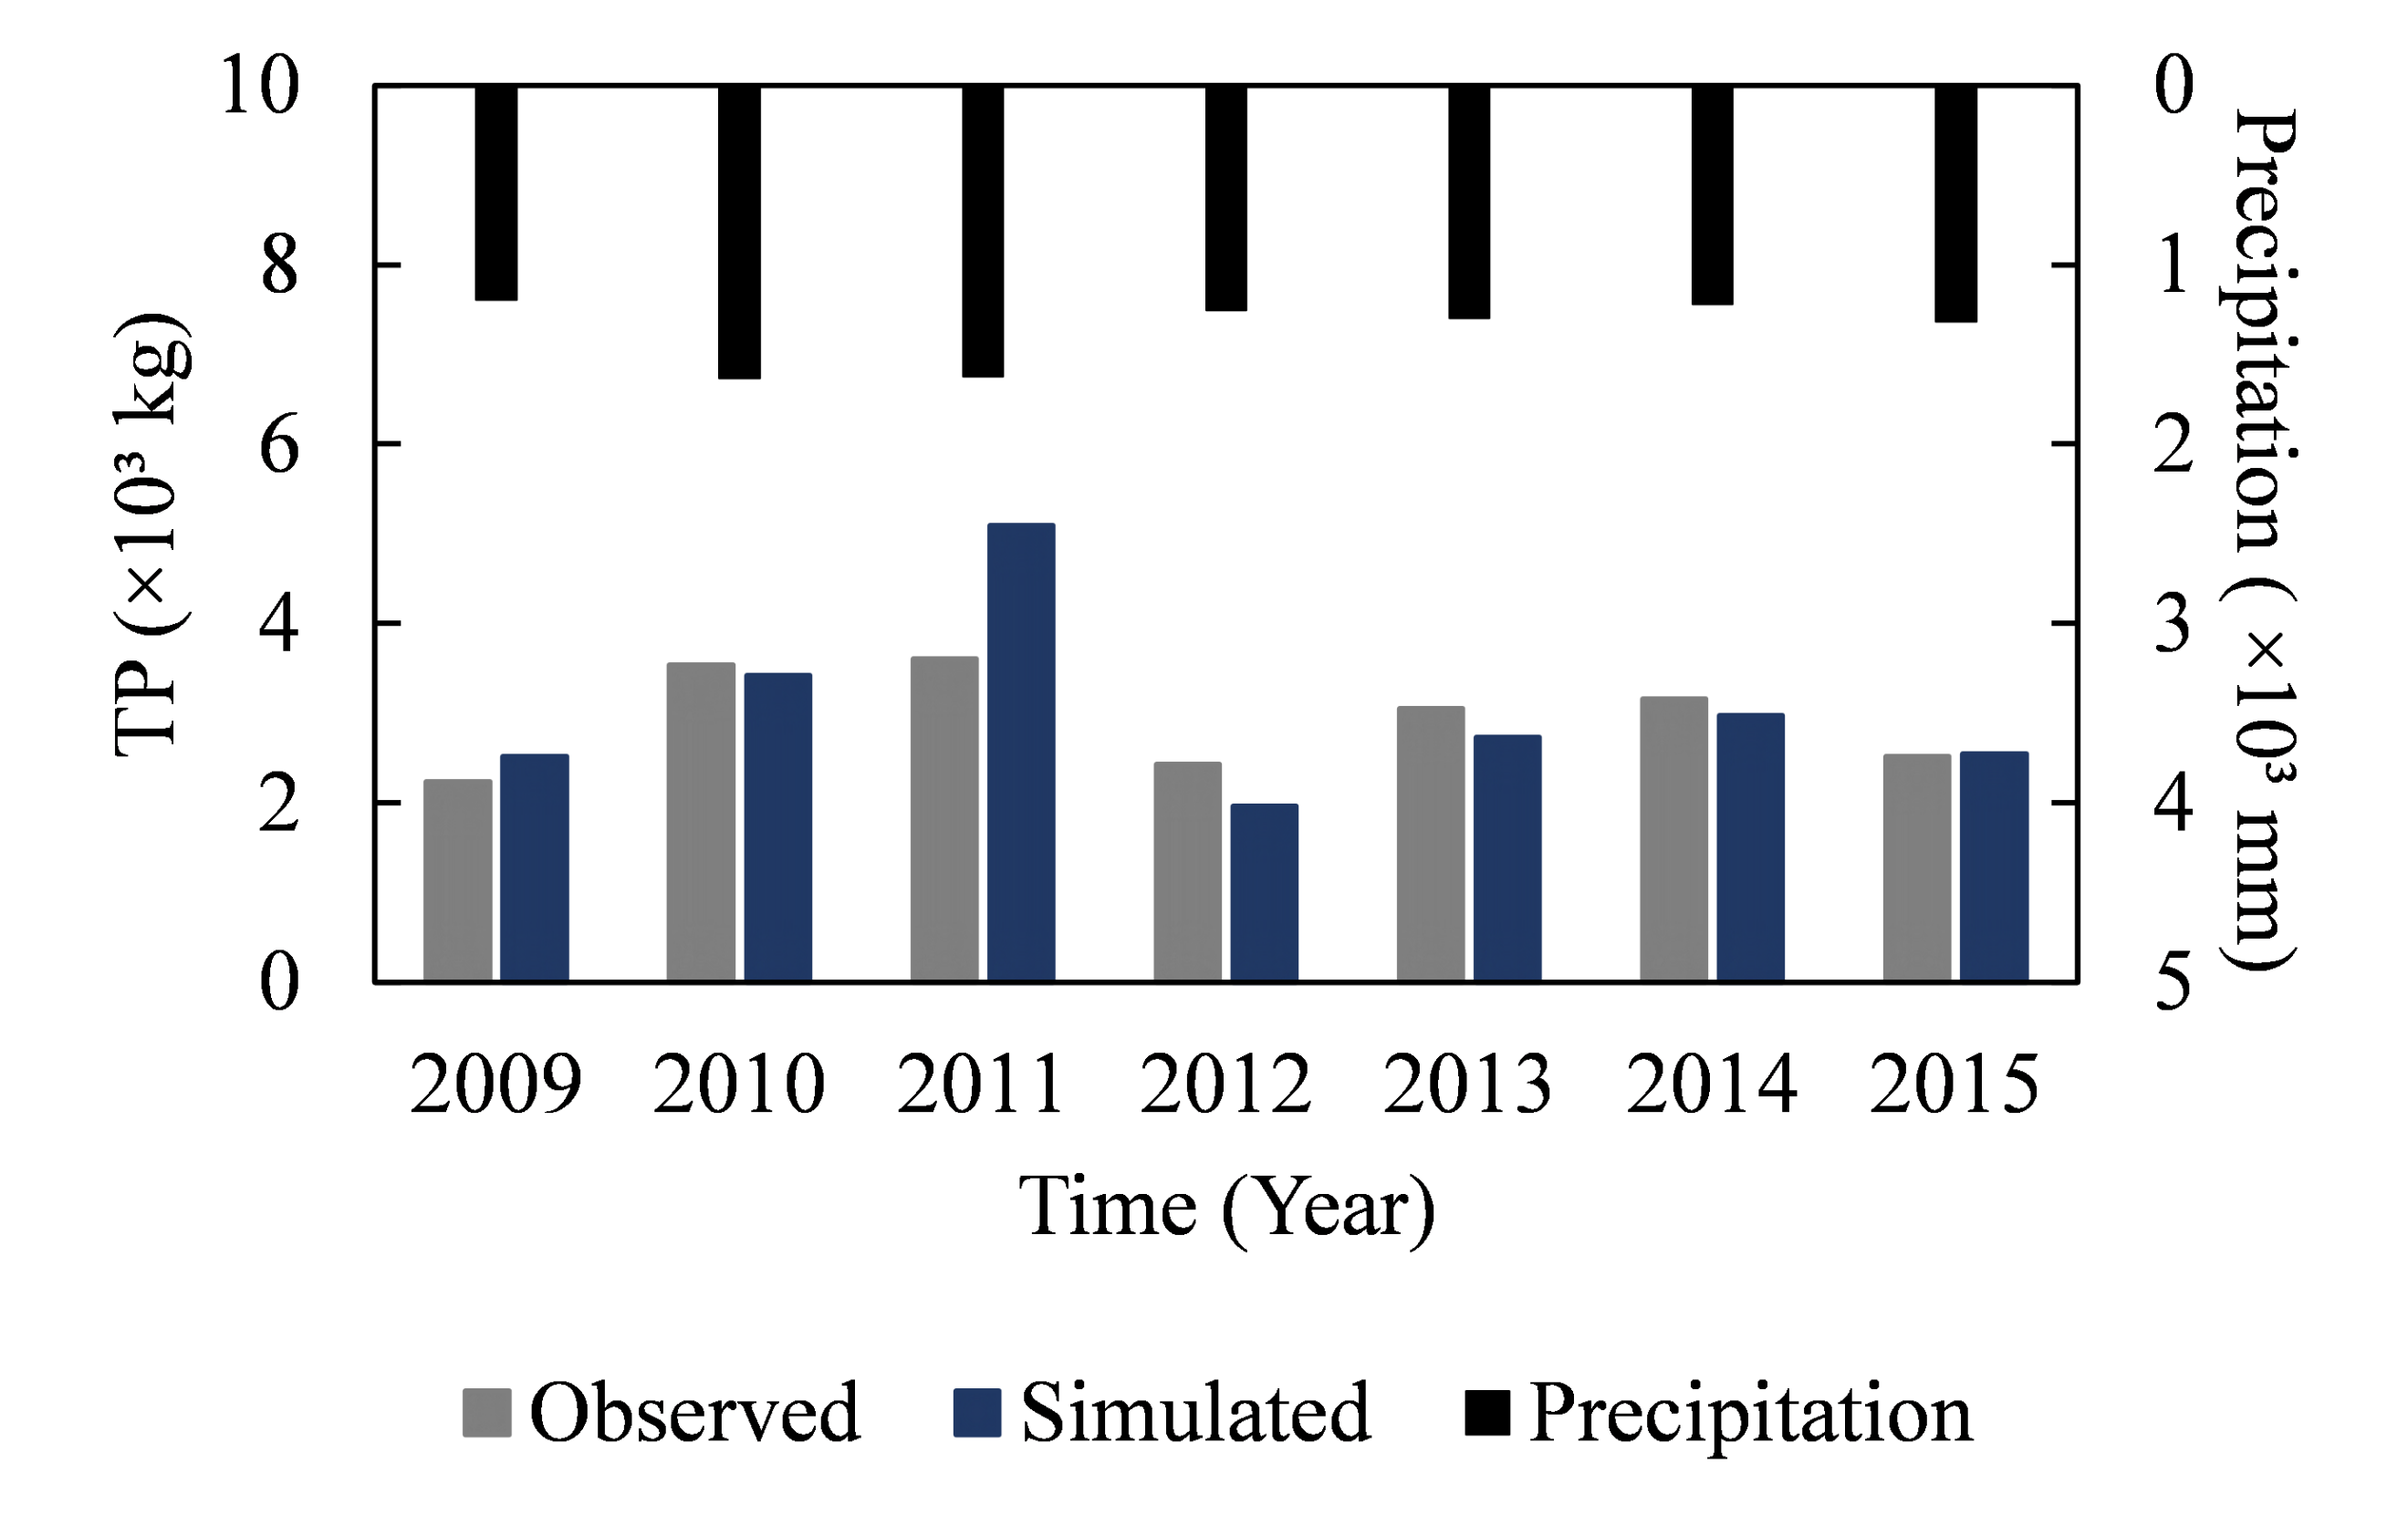
Each equation should be centered within a column width. Equations are to be numbered as (1), (2), etc. This number should be placed on the (or the last) line of the equation and drawn up on the right margin. The equations should be separated from the text by single blank lines left above and below them. If the equation is so long as to be cut, half a line should be left between the lines of the equation. When a mathematical symbol appears in the text, the same font as in the equation should be used. If it is a variable, it should be typed in italics.

2.5 Figures, photos and tables
In general, figures and tables should appear on the same page as they are first mentioned in the text. However, it is acceptable to insert it on the next page. It should be avoided to put all the figures and/or tables at the end of the paper. The figures and the tables should be separated from the text by single blank lines left above and below them.
The English letters used in figures and tables should be typed in typical Roman font face as in the main text.

2.5.1 Figures and photos
The figures, including photographs, should be of good quality to be reproduced. Vector (or draw) images are preferable for figures. The figures are to be numbered as Figure 1, Figure 2, etc., in the order of appearances in the main text. Written in 10pt font, the captions should be placed below the figure and should be centered.

2.5.2 Tables
The Tables are to be numbered as Table 1, Table 2, etc., in the order of appearances in the main text. Written in 10pt font, the captions should be placed above the table and should be centered.

3 A blank line between Chapter and section

3.1 Example
According to the instructions prescribed above, a typical example can be given as follows.
The linear system deduced by Lions (1968) has been analyzed so far (Liu et al., 1992; Ligget and Chen, 1994). At the peak of storm, the source intensity q is estimated as

$$q=q\left(θ\right)=64.7+0.00017θ+4.76θ^{2}$$  $$+3.92θ^{3}-0.40θ^{4}+29.043$$ | (1)

where $θ$= temperature. The continuity equation, which is referred to as state equation, is written as

$$ΔV=q$$ | (2)

where $Δ$=Laplace operator, and V=velocity potential. Using the method proposed by El Harrouni et al. (1996), Eq. (2) is numerically solved in the transformed computational grid shown in Figure 1.

Figure 1: If the caption is a single line, it should be centered. Or the first line should be justified, and the rest lines should be aligned using hanging indent.

4 Conclusions
The instructions to authors who contribute to the Journal of Rainwater Catchment Systems are given. A paper shall be published if and only if the manuscript follows this instruction and passes in the review process. Since this is for manuscripts in English, Instructions to Authors (II) by Usui and Shigen (2022) should be referred when the paper is in Japanese.

Acknowledgements
When author(s) is supported by some fund or person, “acknowledgement” is allowed after the last chapter. Number is unnecessary for the headline. The followings are examples. The authors would like to thank Prof. Loucks, Cornell University for his valuable advice in the numerical analysis. This work was supported by JSPS KAKENHI Grant Number JP12345678.

References
- El, Harrouni, K., Ouazar, D., and Cheng, A. (1996): Parameter identification using fuzzy theory, Computer Methods and Water Resources V, Computational Mechanics Publications, London, pp.87-95.
- Liggett, J.A., and Chen, L. (1994): Inverse transient analysis in pipelines, J. Hydr. Engrg., ASCE, 120(8), pp. 934-955.
- Lions, J.L. (1968): Contrôl Optimal de Systèmes Linéaires, Dunod, Paris, pp.34-89, (in French).
- Liu, F., Feyen, J., and Berlamont, J. (1992): Regulation of unsteady flow in open channels, J. Irrig. and Drain. Engrg., ASCE, 118(10), pp.674-689.
- Mabon, S.A., and Misteli, T. (2005): Differential recruitment of pre-mRNA splicing factors to alternatively spliced transcripts in vivo, PLoS Biol., 3(11), e374, doi: 10.137/journal.pbio.0030374. http://biology.plosjournals. org/perlsev/?request=get-cument&doi=10.1371/jounal. pbio.0030374, (cited 2008-03-09).
- International Organization for Standardization: How ISO develops standards. International Organization for Standardization. http://www.iso.org/iso/about/how_iso_ developes_ standards.htm, (accessed 2008-08-25).
- Usui, I. and Shigen, H. (2022): Instructions to Authors (II) -Preparation of Japanese Manuscripts-，JRCSA, 27(2), pp.70-71, (in Japanese).

Discussion open until ????? ??, ????

